Contents

Installing Prometheus 2

Configure Java Application 2

Configure in Prometheus 3

Setup in Grafana 4

# Installing Prometheus

cd prometheus

sudo ./prometheus --config.file=prometheus.yml

sudo systemctl start prometheus – starts the Prometheus

Checking the status of Prometheus

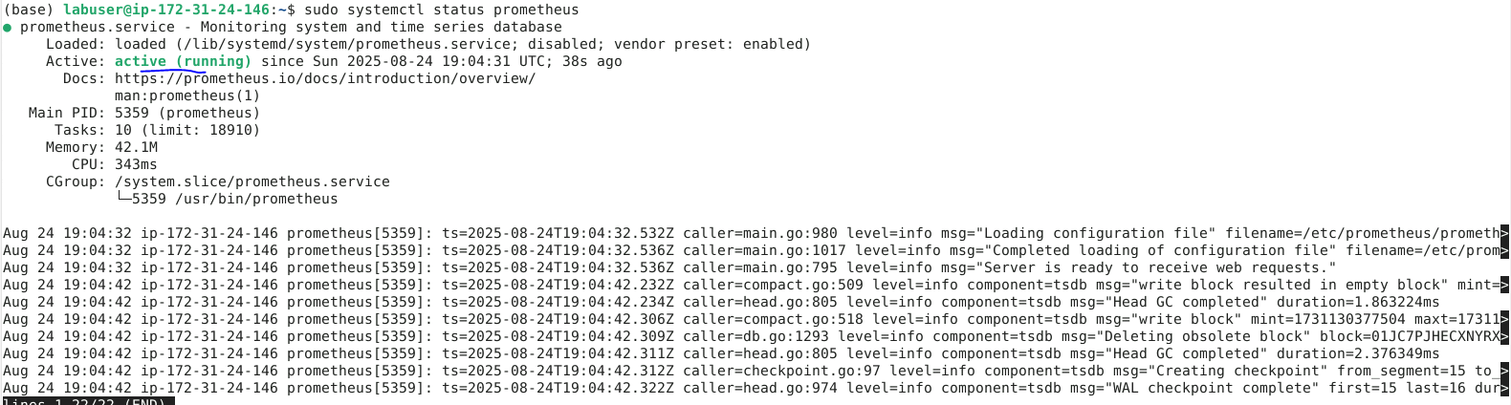

On navigating to <http://localhost:9090/classic/graph> able to see prometheus

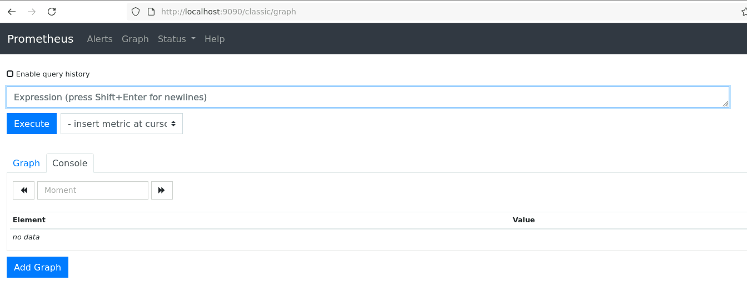

# Configure Java Application

Cloning Java Application

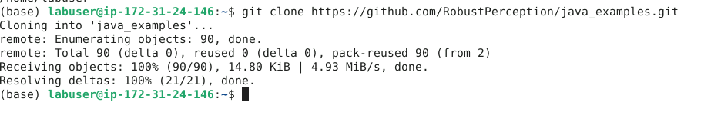

Once navigating into /home/labuser/java_examples/java_simple and running mvn package able to see build success

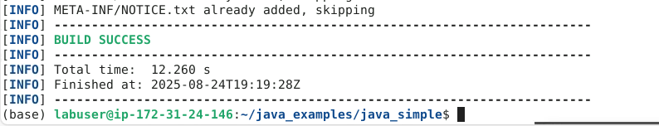

When performing curl command,



On Executing **curl localhost:1234/metrics**

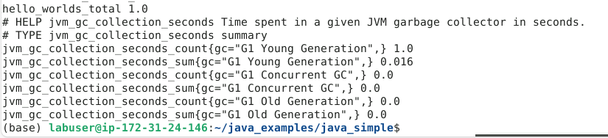

# Configure in Prometheus

Navigate to prometheus-2.54.0.linux-arm64 and sudo vi java-metrics.yaml and added the following and save the file

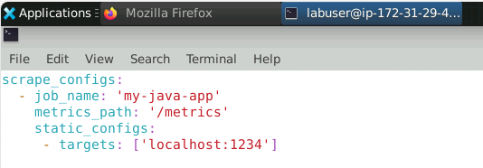

Started Prometheus

**sudo ./prometheus --config.file=java-metrics.yaml**

Navigating to localhost:8080 multiple time and keeping the graph as 1m, able to see the spike

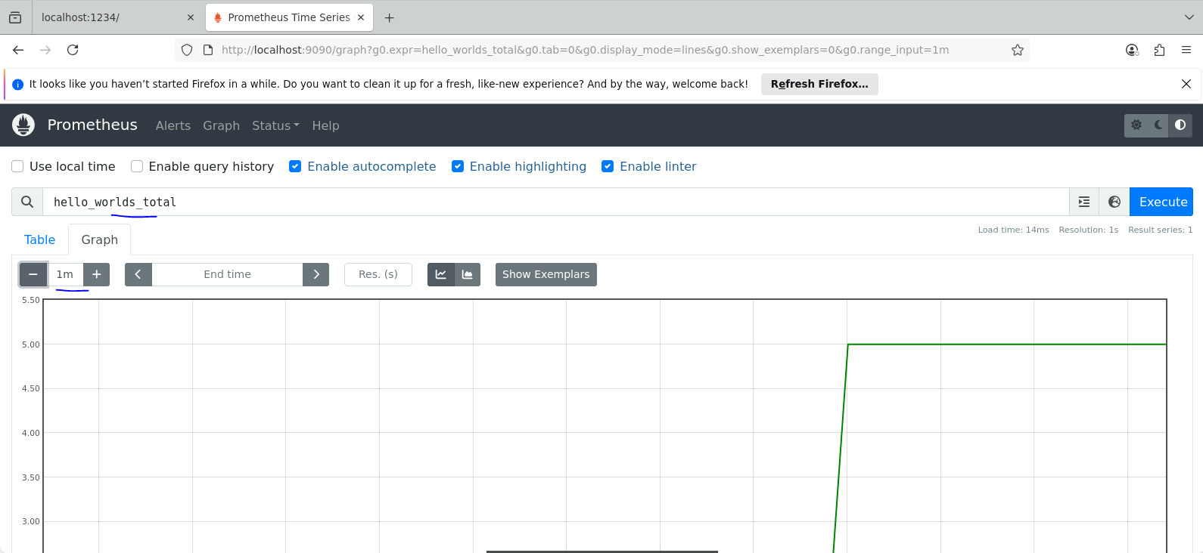

jvm_memory_bytes_committed shows above 250MB

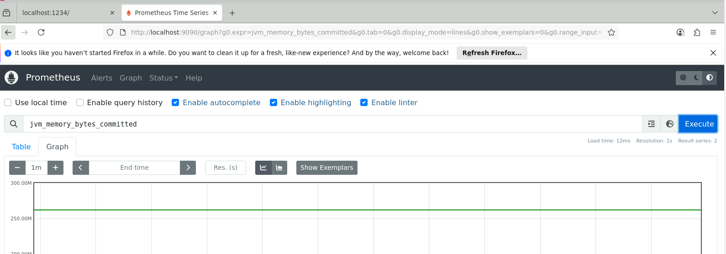

# Setup in Grafana

Navigate to localhost:3000

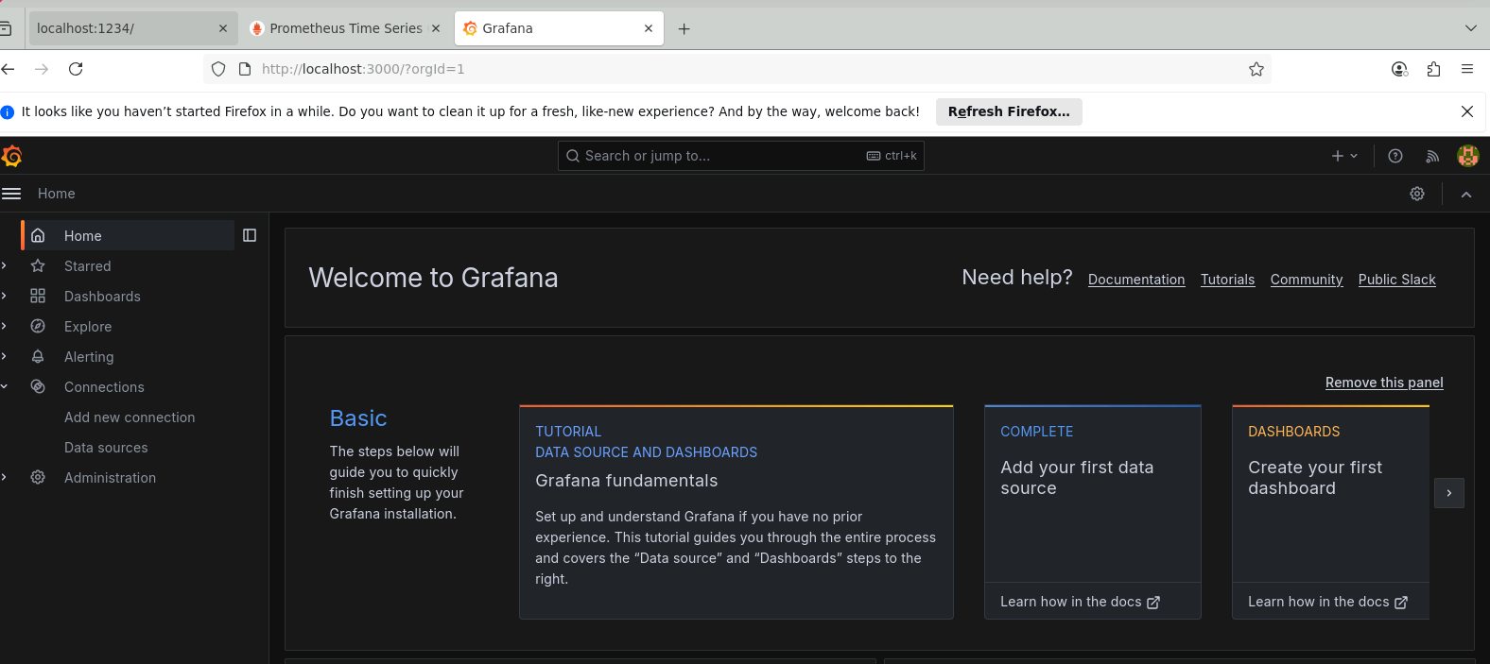

Click on to Datasources and select Prometheus

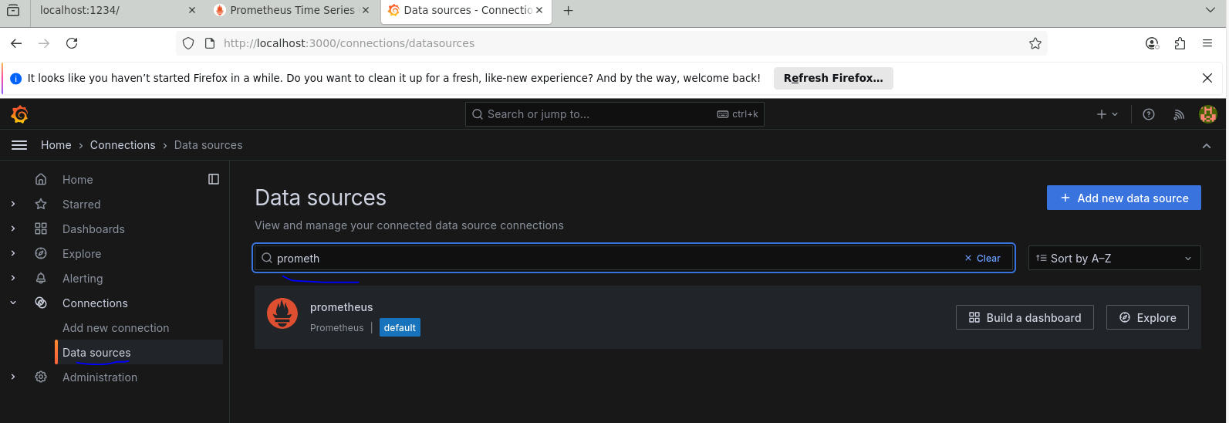

Enter Prometheus server url

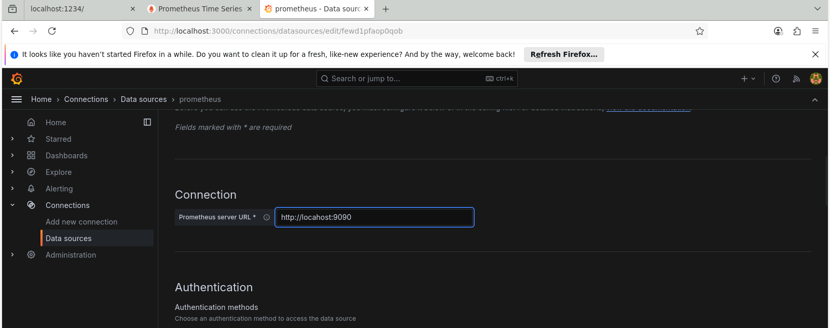

While save and test



Creating a new dashboard

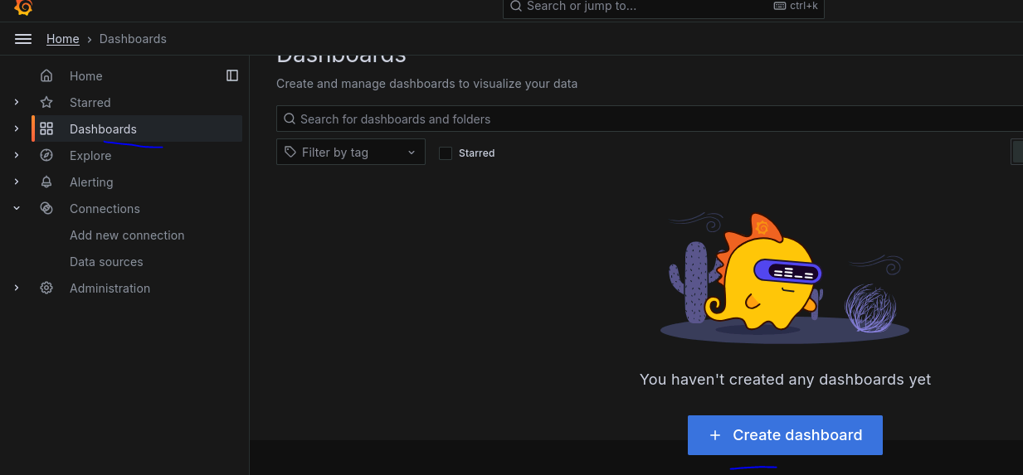

Click Add Visualization

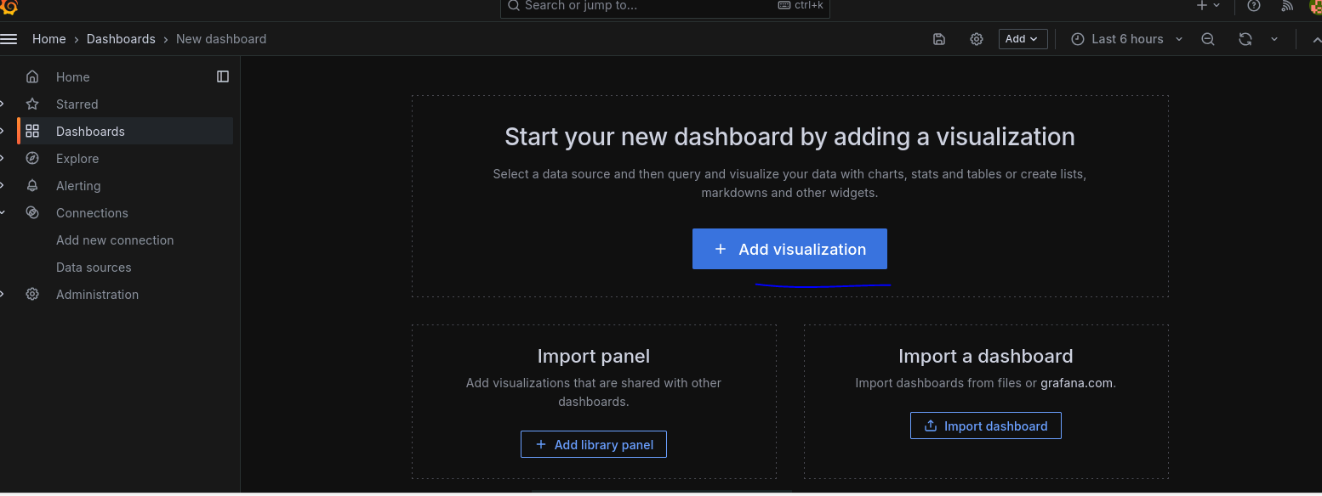

Select Prometheus data source

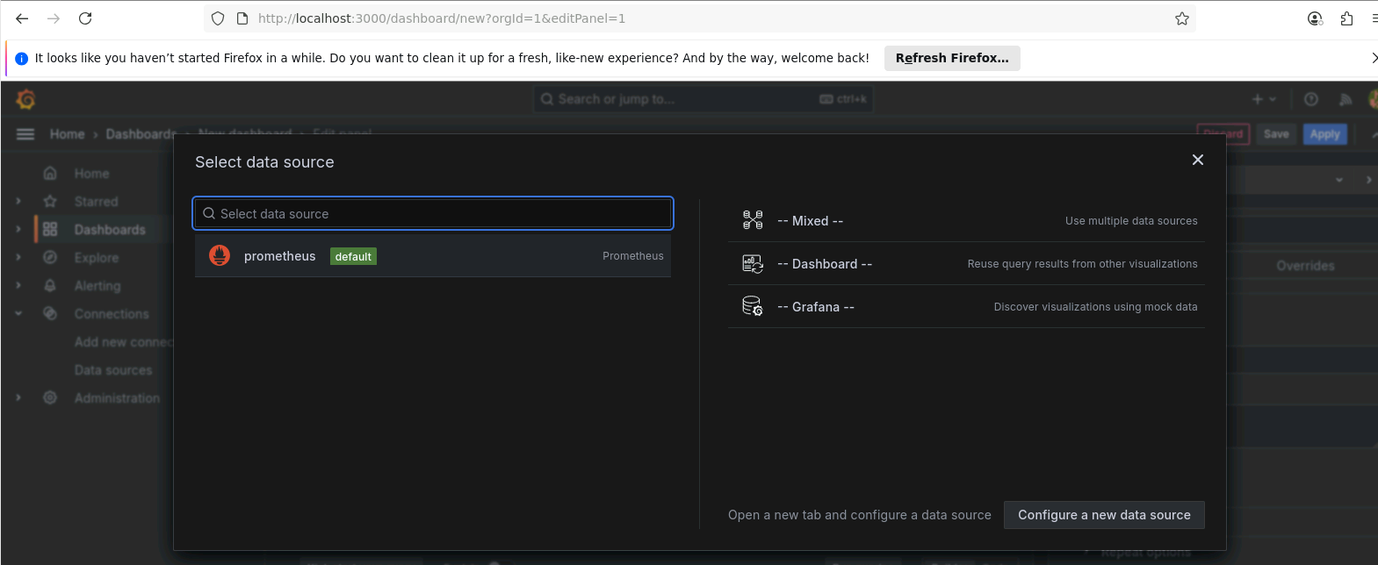

In the metric, select hello_worlds_total

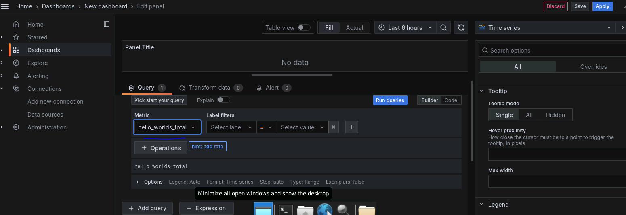

On selecting past 5 min, shows java application

